**Products and Categories**

In this assignment, you will be creating an application that will keep track of products and categories

ERD and Wireframe

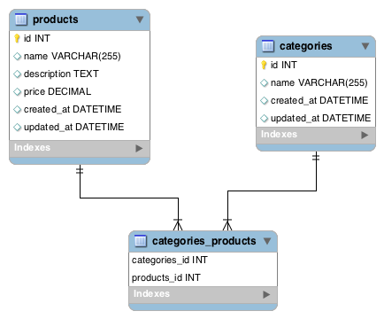

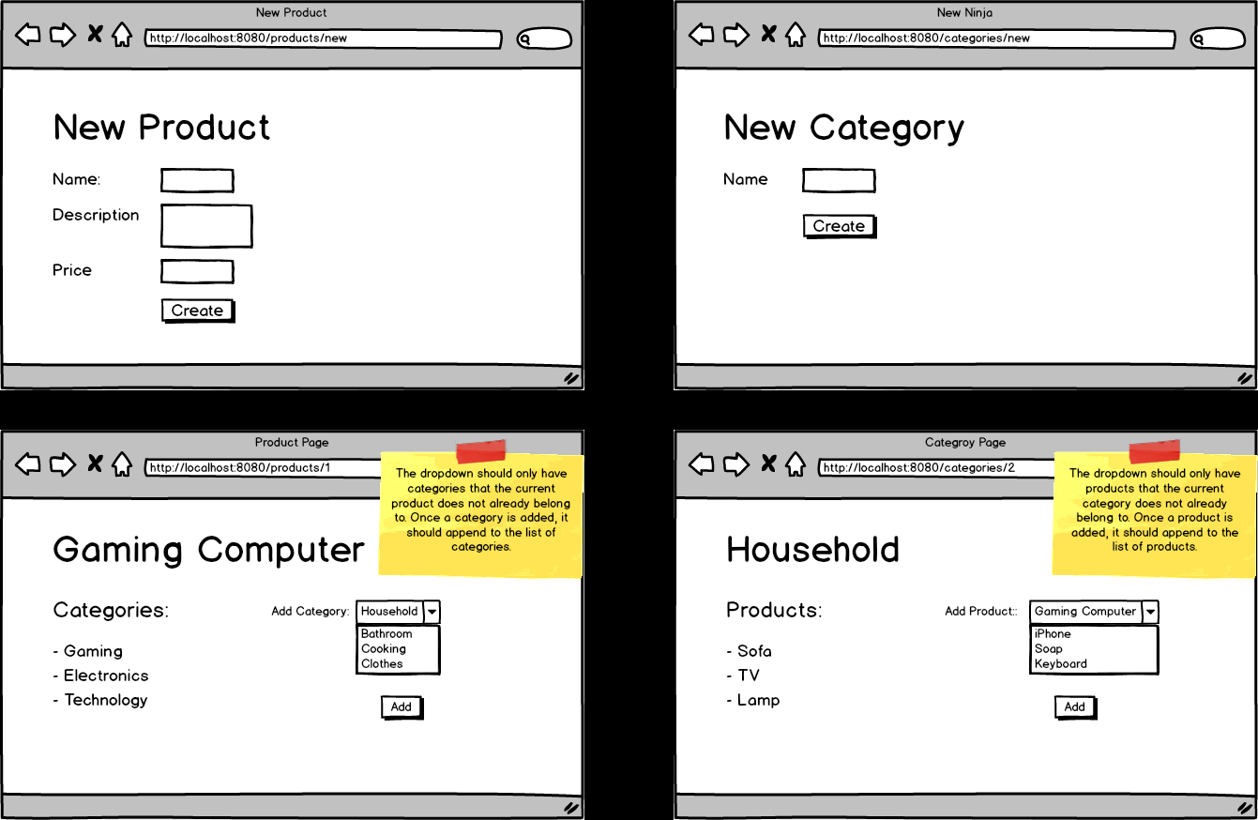

Topics:

* Many-to-Many relationships
* JPA methods

Tasks:

* Allow users to create a product.
* Allow users to create a new category.
* In the products show page, allow users to add a category to a specific product.
* In the categories show page, allow users to add a product to a specific category